**A user story  
Khayal (We Care)**

**The first story:**

Consider you are travelling to hospital which is 2 - 3 hours away for an underlying problem you might have had for months, as you arrive there you see there seems to be a bit of rush to see the doctor that you had came to see, now after waiting for an hour it’s finally your turn, as you enter the doctor’s office, and explain your issues he asks for your previous checkup reports so he can better help you, now since you were in a hurry you forgot your reports at home. Oh no. So what will you do now? Go back and come back again going through the same time consuming journey and the hour long wait? To solve this issue our application is there to help.

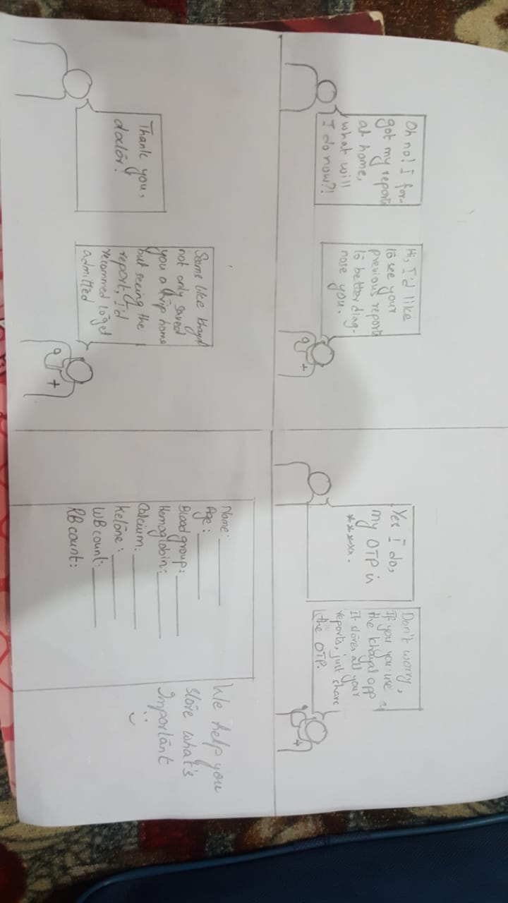

Not only this, even if you don’t have an internet connection the doctor can request you for an One Time Password where he will be able to see your reports for a specific time period.

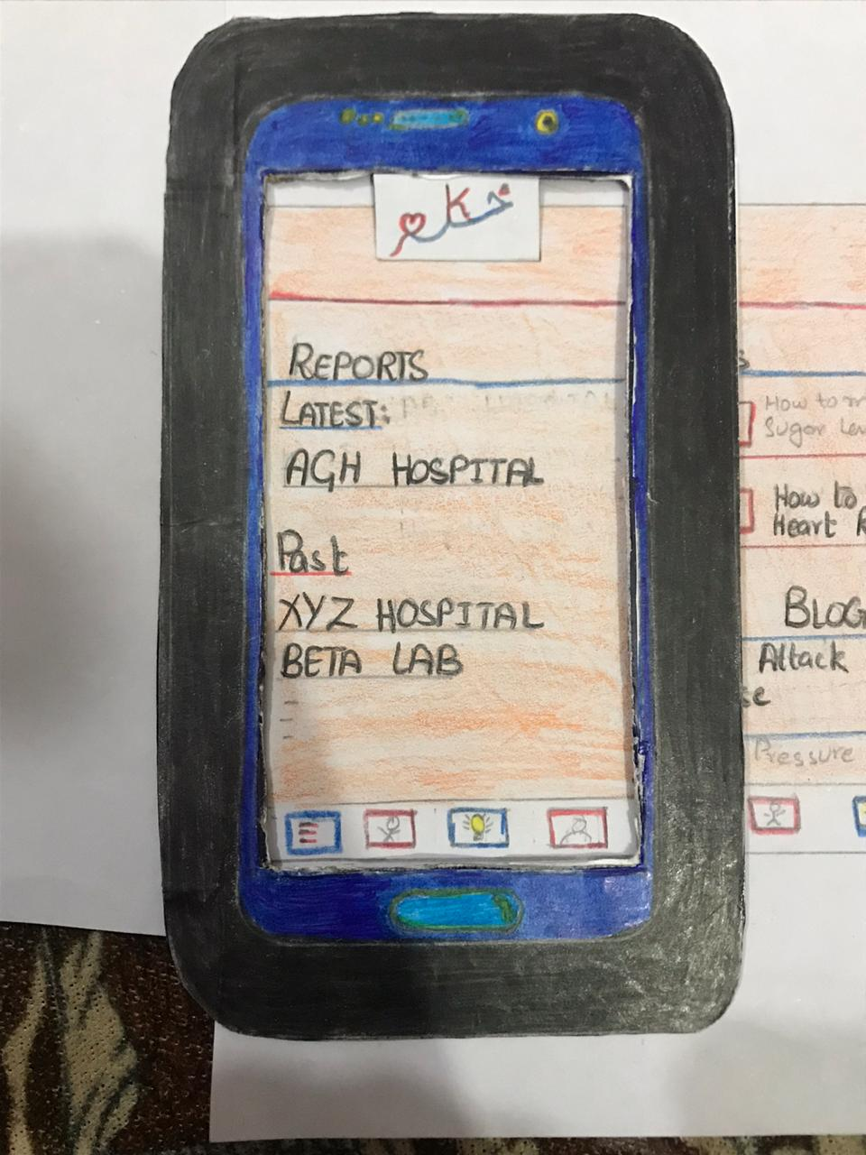

**The second story:**

Consider you are be more active and would like to record your daily workout routine, so you can better yourself everyday, our app comes in handy there as well, as you will be able to learn new exercises and record your workout every day!

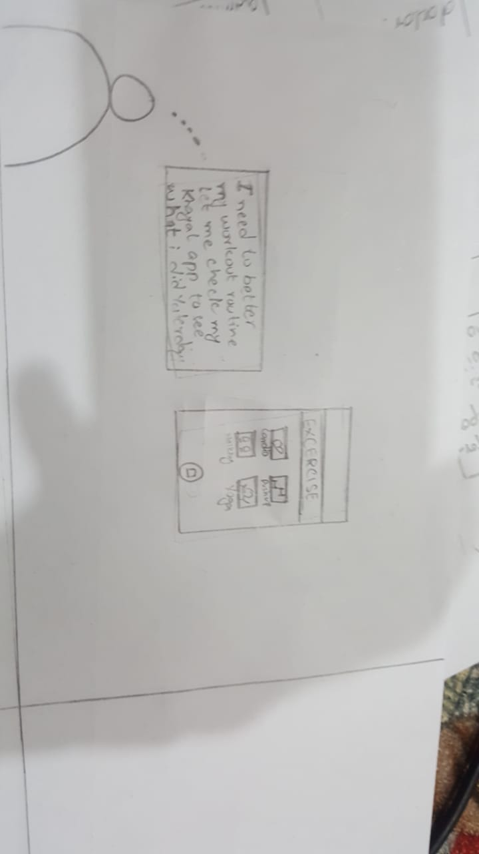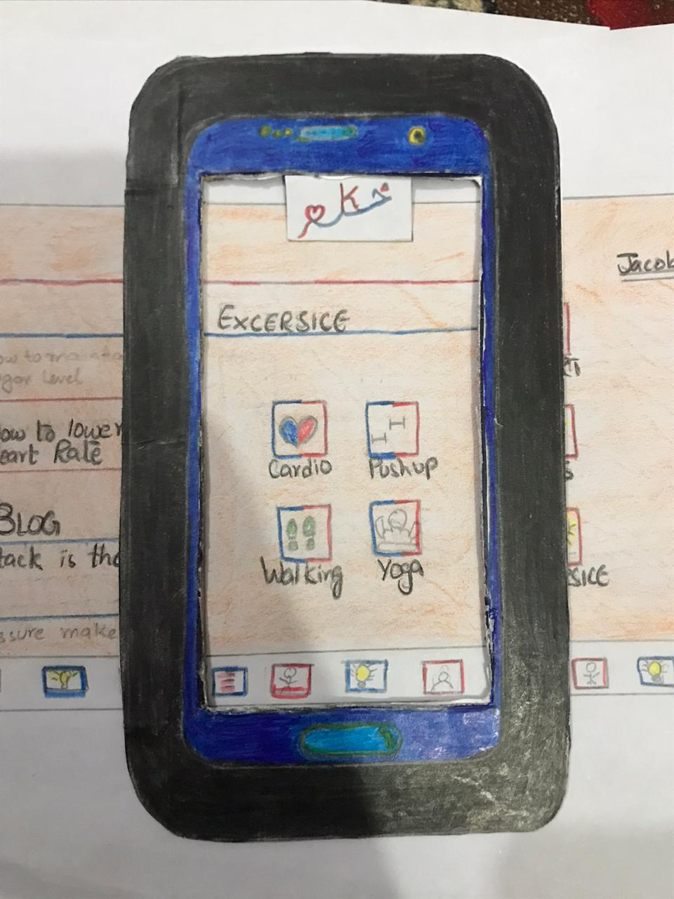

**The third story:**

Consider you have accidentally hurt yourself, and although it hasn’t impared your ability to drive, you need to look up nearby hospitals, when you open google maps you will need to search for nearby hospitals or search a specific name, wouldn’t be much easier if you were able to open up the map and it would automatically show you nearby hospitals? This is where our app comes in as well

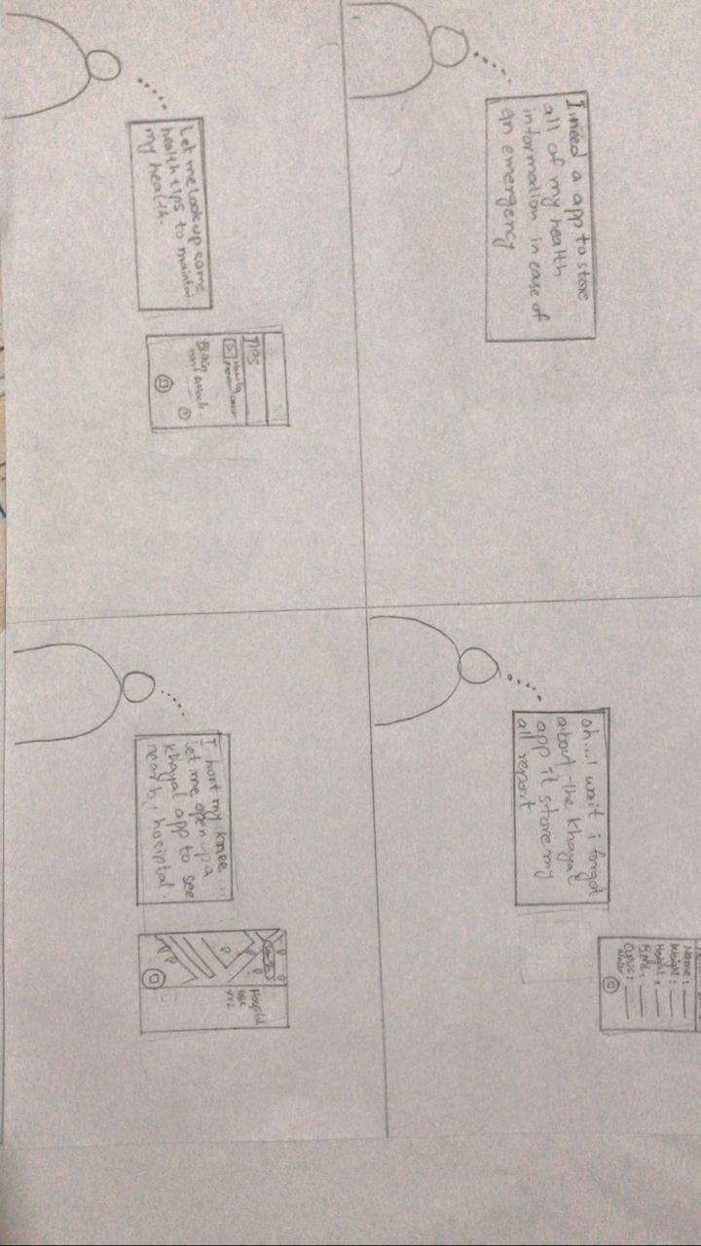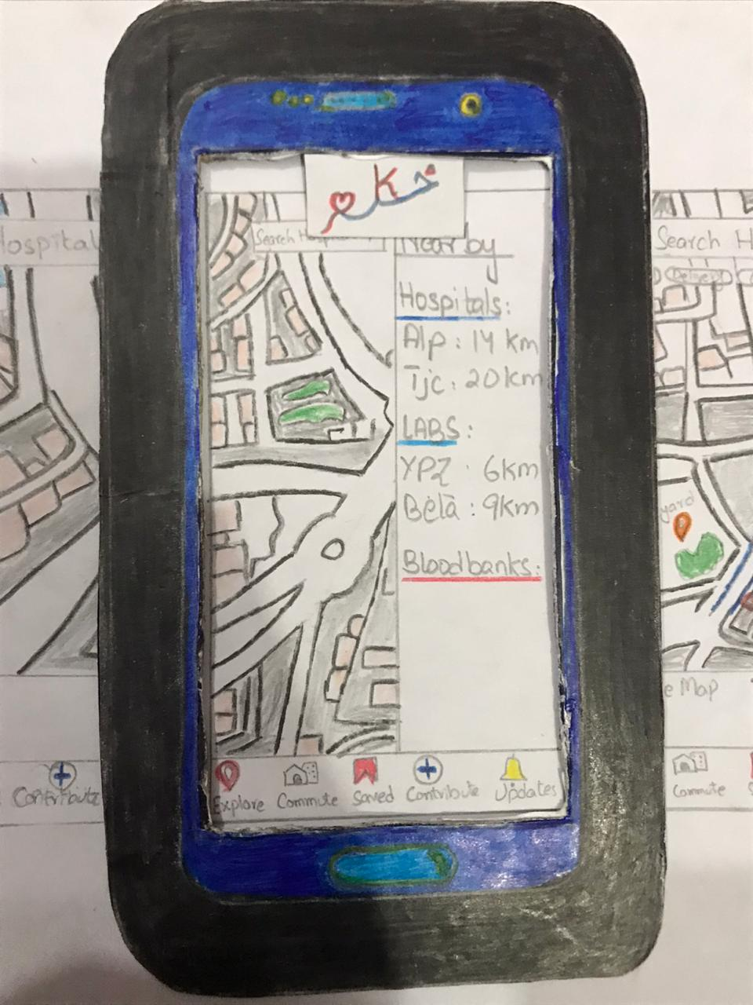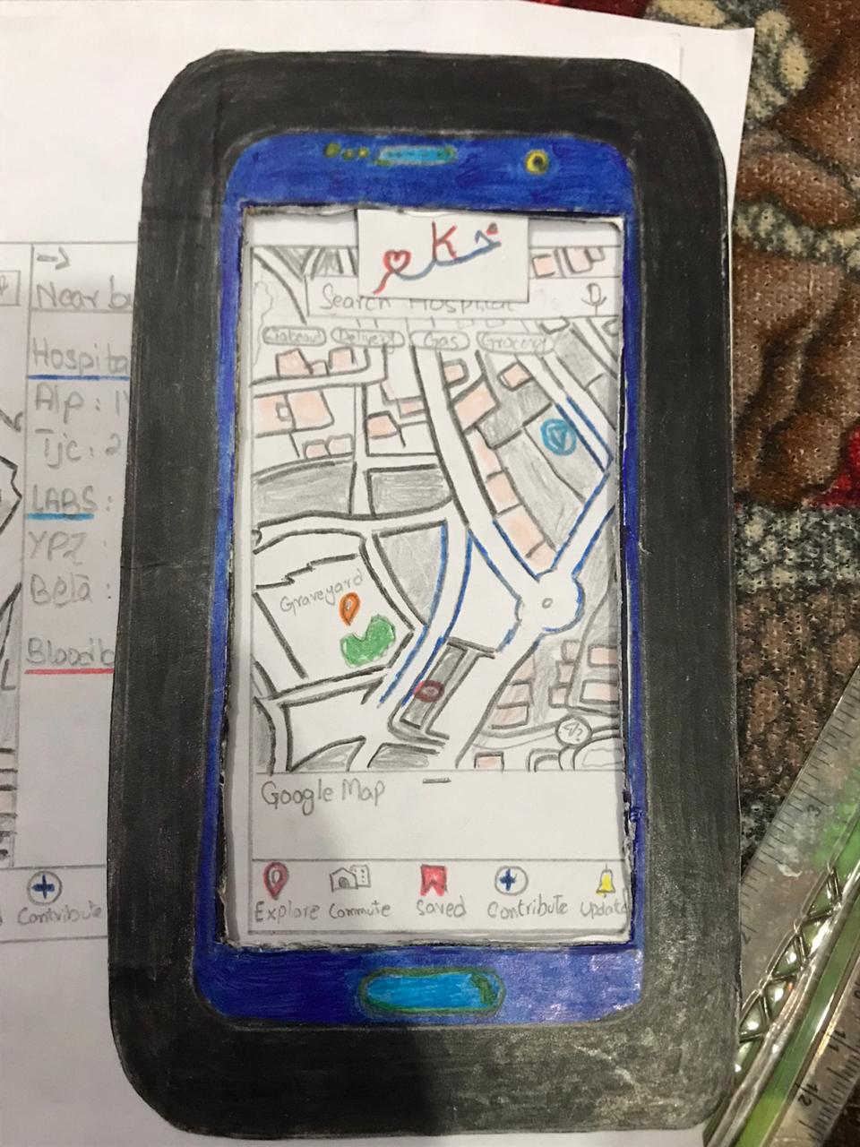

Not only will you be able to see the nearby hospitals, labs and other medical facilities but will also be able to navigate to that place from your current location! We are trying to help anyone in medical assistant as much as we can remotely.

**The Fourth Story**

A human body undergoes changes every few months, you body mass index will change based on your weight. You can also live a healthier lifestyle by keeping how many cups of water you are drinking in a day, this information can all be stored with our app!